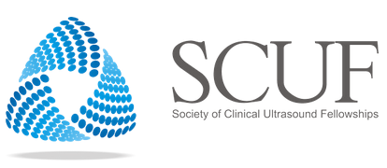

October 16th, 2020 SCUF 2020 Virtual Conference
Zoom details will be emailed to registrants closer to the date

Main Room
10:00-10:15 | Introduction and Welcome
10:15- (10:45) 10:50 | Keynote: Pioneers and Frontiers - POCUS Past, Present and Future | Mary Beth Phelan, MD
10:50-12:00 | Breakout Session 1
12:00-12:50 | Fellow Lightning Talks
12:50-13:30 | LUNCH | (Performance)  (Vendor Showcase)
13:30-14:15 | EUFAC & AEMUS Report, Q&A
14:15-15:15 | Tech Summit and Breakout Session 2
15:15-15:30 | Wrap Up and End
15:30 - | Virtual Happy Hour

Breakout Session 1 - Room A
11:00-12:15 | Credentialing in a Large Healthcare System  Implementing a Nurse PIV program  Ultrasound and APPs  Hospital Medicine POCUS program | Courtney Smalley, MD  Jodi Jones, MD  Dayna Jaynstein, MSPAS, PA-C  Tanping Wong, MD

Breakout Session 1 - Room B
11:00-12:15 | Walking Head On Into Research: My Path  Detecting Venous Congestion with POCUS: Game Changer  POCUS and Gamification: All Fun and Games? | Anthony Weekes, MD  Yanika Wolfe, MD  Stephanie Leung, MD

Breakout Session 2 - Room A
14:15-15:15 | Communities of Practice: Internal Medicine, Pediatrics and Intensive Care | Atim Uya, MD  Robert Strony, DO  Renee Dversdal, MD  Becky Burk, MD

Breakout Session 2 - Room B
14:15-15:15 | Jr. Faculty / Fellow / Resident meet & greet  - Career pearls  - Lessons learned | Alan Chiem  Creagh Boulger  Javier Rosario

Breakout Session 2 - Tech Summit (Main Room)
14:15-15:15 | Interface with our Vendors on topics regarding Innovations and Education | Rachel Liu  Jason Nomura  Matt Flanigan  Nova Panebianco

